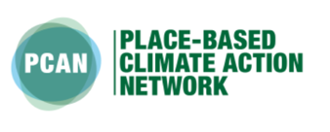

A summary carbon roadmap

for Yorkshire and Humber

Andy Gouldson, Andrew Sudmant and Millie Duncan
University of Leeds

Contact: a.gouldson@leeds.ac.uk

www.pcancities.org

Please reference as: Gouldson, A. Sudmant, A. Duncan, A. (2021). “A summary carbon roadmap for Yorkshire and Humber”. Place-based Climate Action Network, https://pcancities.org.uk/

Highlights

- Scientific evidence calls for rapid reductions in global carbon emissions if we are to limit average levels of warming to 1.5 degrees and so avoid the risks associated with dangerous or runaway climate change.
- Globally, the IPCC suggests that we will have used up the global carbon budget that gives us a good chance of limiting warming to 1.5 degrees within a decade. This science underpins calls for the declaration of a climate emergency.
- Dividing the global carbon budget up by population gives Yorkshire and Humber a total carbon budget of 189 million tonnes from 2021. Based only on the fuel and electricity used within its boundaries, Yorkshire and Humber currently emits c.2.9 million tonnes of carbon a year, meaning that it would use up its carbon budget in just over 6 years.
- Carbon emissions from Yorkshire and Humber have fallen by 48% since 2005. With on-going decarbonisation of electricity, and taking into account population and economic growth, we project that Yorkshire and Humber’s 2005 level of emissions will have fallen by 49% by 2050.
- If it is to stay within its carbon budget, Yorkshire and Humber needs to add to the 48% reductions already achieved to secure 72% reductions on its 2005 level of emissions by 2025, 85% by 2030, 92% by 2035, 96% by 2040, 98% by 2045 and 99% by 2050. This means that the majority of all carbon cuts need to be delivered in the next ten years.
- To meet these targets, Yorkshire and Humber will need to adopt low carbon options that close the gap between its projected emissions in 2050 and net zero emissions.
- The analysis shows that Yorkshire and Humber could close this gap by 35% through the adoption of cost-effective options in houses, public and commercial buildings, transport and industry.
- Adopting these options would reduce Yorkshire and Humber’s total energy bill by £2.4 billion p.a. whilst also creating 32,850 years of employment in the region.
- The most carbon effective options for the region to deliver these carbon cuts include improved heating, lighting and insulation in houses, cooling and insulation in offices, shops and restaurants and the wider up-take of electric vehicles.
- The analysis also shows that Yorkshire and Humber could close the gap by 58% through the adoption of options that already available but that may not pay for themselves directly through the energy they save. Many of these options would generate indirect benefits, for example relating to reduced congestion and air pollution and improved public health.
- This means that although it can achieve a lot by focusing on already established options, Yorkshire and Humber still has to identify some other possibly more innovative options that could deliver the last 42% of the gap between its projected emissions in 2050 and a net zero target.

Introduction

Climate science has proven the connection between the concentration of greenhouse gases in the atmosphere and the extent to which the atmosphere traps heat and so leads to global warming. The science tells us – with a very high level of confidence – that such warming will lead to increasingly severe disruption to our weather patterns and water and food systems, and to ecosystems and biodiversity. Perhaps most worryingly, the science predicts that there may be a point where warming becomes self-fuelling – for example where it leads to the thawing of permafrost so that they release significant quantities of greenhouse gases that then lead to more warming. Beyond this point or threshold, the evidence suggests that we may lose control of our future climate and become subject to what has been referred to as dangerous or runaway climate change.

Until recently, scientists felt that this threshold existed at around 2 degrees centigrade of global warming, measured as a global average of surface temperatures. However, more recent scientific assessments (especially by the Intergovernmental Panel on Climate Change or IPCC in 2017) have suggested that the threshold should instead be set at 1.5 degrees centigrade. This change in the suggested threshold from 2 degrees to 1.5 degrees has led to calls for targets for decarbonisation to be made both stricter (e.g. for the UK to move from an 80% decarbonisation target to a net zero target), and to be brought forward (e.g. from 2050 to 2030).

Globally, the IPCC suggests that from 2020 we can only emit 344 billion tonnes of greenhouse gases if we want to give ourselves a 66% chance of avoiding dangerous climate change. Globally, we are currently emitting over 37 billion tonnes of greenhouse gases every year. That means that we will have used up our global carbon budget within a decade. It is this realisation – and the ever accumulating science on the scale of the impacts of climate change - that led to calls for organisations and areas to declare a climate emergency and to develop and implement plans to rapidly reduce GHG emissions.

Measuring Your Carbon Footprint

Any area’s carbon footprint – measured in terms of the total impact of all of its greenhouse gas emissions - can be divided into three types of greenhouse gas emissions.

- Those coming from the fuel (e.g. petrol, diesel or gas) that is directly used within an area and from other sources such as landfill sites or industry within the area. These are known as Scope 1 emissions.
- Those coming from the electricity that is used within the area, even if it is generated somewhere else. These are known as Scope 2 emissions. Together scope 1 and 2 emissions are sometimes referred to as territorial emissions.
- Those associated with the goods and services that are produced elsewhere but imported and consumed within the area. After taking into account the carbon footprint of any goods and services produced in the area but that are exported and consumed elsewhere, these are known as Scope 3 or consumption-based emissions.

In this report, we focus on scope 1 and 2 emissions, and we exclude consideration of long-distance travel and of scope 3 or consumption-based emissions. We do this because scope 1 and 2 emissions are more directly under the control of actors within an area, and because the carbon accounting and management options for these emissions are better developed. We stress though that emissions from longer distance travel (especially aviation) and consumption are very significant, and also need to be addressed.

Yorkshire and Humber’s Baseline Emissions

Analysis shows that Yorkshire and Humber’s baseline (scope 1 and 2) emissions have fallen by 48% since 2005, due to a combination of increasingly decarbonised electricity supply, structural change in the economy, and the gradual adoption of more efficient buildings, vehicles and businesses.

With full decarbonisation of UK electricity by 2045, and taking into account economic growth (assumed at 2.5% p.a.), population growth (assumed at 0.1% p.a.) and on-going improvements in energy and fuel efficiency (assumed at 1% p.a), we project that Yorkshire and Humber’s baseline (scope 1 and 2) emissions will fall by a further 17% by 2050, or by a total of 49% between 2005 and 2050.

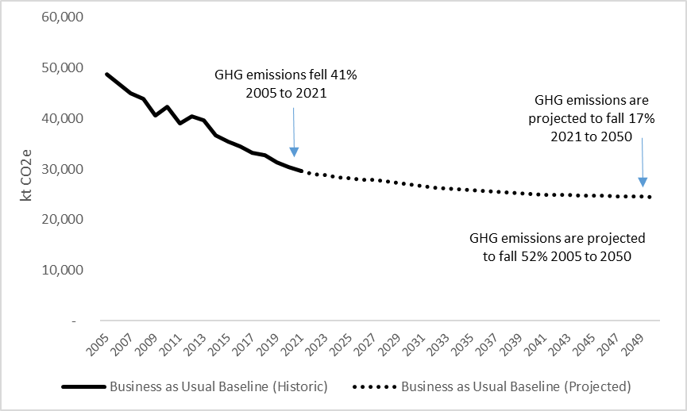

Figure 1: Scope 1 and 2 GHG emissions 2005 to 2050 for Yorkshire and Humber

Currently, 25% of Yorkshire and Humber’s emissions come from the transport sector, with housing then responsible for 29% of emissions, public and commercial buildings for 25% and industry 21%. By 2050, we project emissions from transport will slightly increase and emissions from public/commercial buildings will slightly decrease, with the emissions from housing and industry remaining the same.

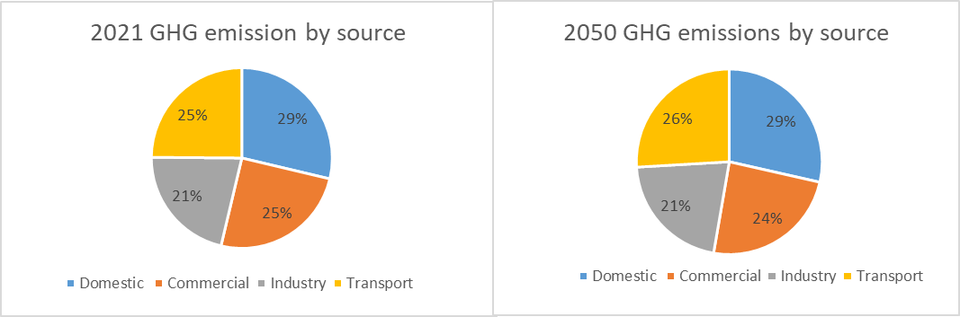

Figure 2: Emissions by sector

Science-based targets for Yorkshire and Humber

The Inter-governmental Panel on Climate Change (IPCC) has argued that from 2018, keeping within a global carbon budget of 420 gigatonnes (i.e. 420 billion tonnes) of GHG emissions would give us a 66% chance of limiting average warming to 1.5 degrees and therefore avoiding dangerous levels of climate change, this leaves less than 300 gigatonnes from 2021. If we divide this global figure up on an equal basis by population, this gives Yorkshire and Humber a total carbon budget of 189 megatonnes (i.e. 189 million tonnes) from 2020.

At current rates, Yorkshire and Humber would use up this budget in just over 6 years. However, Yorkshire and Humber could stay within its carbon budget by reducing its emissions by 7.3% year on year. This would mean that Yorkshire and Humber’s commits to transition from its current position where it’s emissions are 48% lower than 2005 levels to a pathway where its emissions are 72% lower than 2005 levels by 2025, 85% by 2030, 92% by 2035, 96% by 2040, 98% by 2045 and 99% by 2050. Such a trajectory would mean that the majority of all carbon cuts need to be delivered in the next ten years.

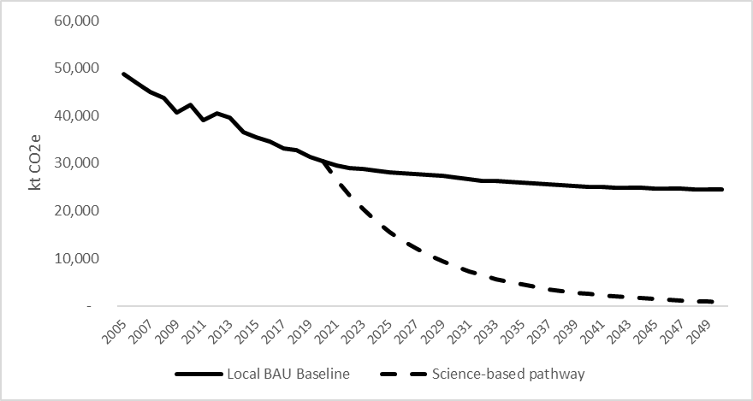
Figure 3: BAU and science-based emissions pathways

What are the Options for Yorkshire and Humber?

Some of what needs to be done will happen outside Yorkshire and Humber – for example through the on-going decarbonisation of electricity or the development of electric vehicles. However, numerous options could also be adopted within Yorkshire and Humber to reduce energy use and carbon emissions in homes, buildings, transport and industry.

All of the evidence suggests that there are unlikely to be many ‘silver bullets’ that lead to dramatic step changes in a regions carbon footprint, but that instead multiple options have to be adopted across all sectors. Our analysis includes assessment of the potential contribution of c.130 energy saving or low carbon measures for:

- households and other public/commercial buildings (better insulation, improved heating, more efficient appliances, some small scale renewables)
- transport (more walking and cycling, enhanced public transport, electric and more fuel efficient vehicles) and
- industry (better lighting, improved process efficiencies and a wide range of other energy efficiency measures).

We divide these measures into two groups.

- The cost-effective options where the direct costs of adopting them are outweighed by the direct benefits that they generate through the energy savings they secure. These options may also generate indirect benefits, for example through job creation, fuel poverty and improved air quality and public health.
- The technical potential options where the direct costs are not (at present) covered by the direct benefits. However, the cost of many low carbon options is falling quickly, and again these options could generate important indirect benefits such as those listed above.
As it is unlikely that adopting all of the cost-effective or technically viable options will enable an area to reach net-zero emissions, we also highlight the need for a third group of measures:

- The innovative or ‘stretch’ options that includes low-carbon measures that are not yet widely adopted. Some of the options within this group may well be cost and carbon effective, and they may also generate significant indirect benefits, but whilst we can predict their carbon saving potential, data on their costs and benefits is not yet available.

What this Means for Yorkshire and Humber

Our analysis predicts that the gap between the Yorkshire and Humber’s business as usual emissions in 2050 and the net zero target could be closed by 35% through the adoption of cost-effective options and 58% through the adoption of both the cost-effective and technically viable options. This means that Yorkshire and Humber still has to identify the innovative or stretch options that could deliver the last 42% of the gap between the business as usual scenario and net zero.

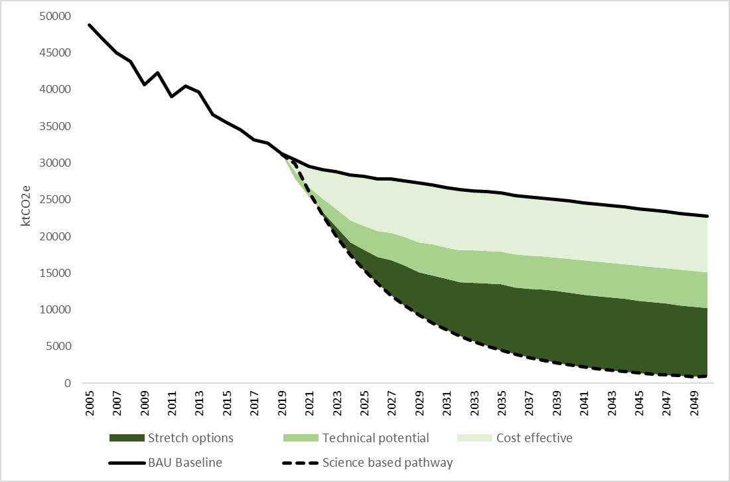
Figure 4: Baseline with the contributions of cost-effective, technical potential and stretch options

Exploiting the cost-effective options in households, public and commercial buildings, transport and waste could be economically beneficial. Although such measures would require investments of £15.5 billion, once adopted they would reduce Yorkshire and Humber’s total energy bill by £2.4 billion p.a. whilst also creating 32,850 years of employment. However, exploiting the technically viable options would be more expensive, at least under current prices.

Across the two categories (cost-effective and technically viable options), league tables of the most carbon and cost effective options are presented below.

Most carbon effective options:

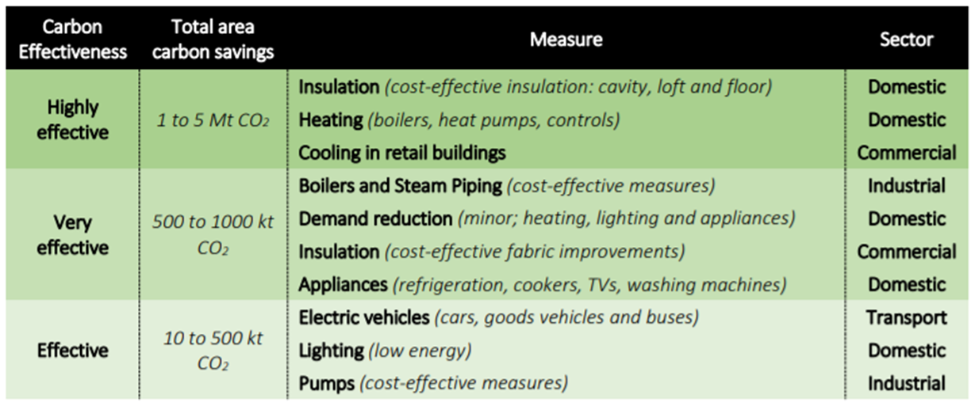

Most cost-effective options:

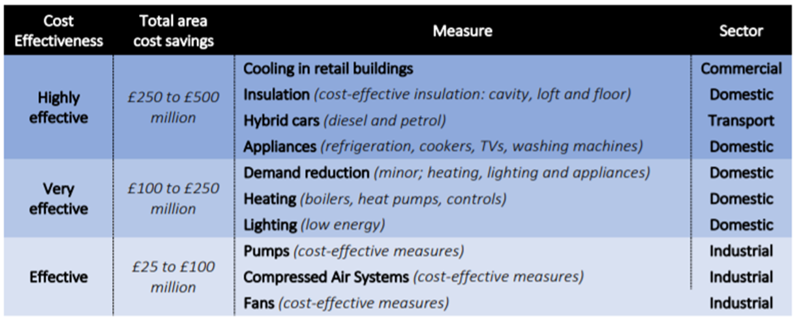

Some of the ideas for innovative options identified elsewhere, that could also be considered for Yorkshire and Humber, include targeting a transition to net zero homes and public/commercial buildings by 2030, promoting the rapid acceleration of active travel (e.g. walking and cycling) and the adoption of electric vehicles, tackling food waste, reducing meat and dairy consumption and reducing concrete and steel consumption/promoting adoption of green infrastructure.

Next Steps for Yorkshire and Humber

Based on the experiences of other UK cities and areas, we would recommend the following basic steps:

- Declaring a climate emergency and adopting 5 yearly carbon reduction targets;
- Developing, consulting on and publishing a climate action plan that sets out the steps needed to meet those targets and that enables capacities to be built, key barriers to be identified and removed and progress to be tracked;
- Adopting an independent climate commission to act as a critical friend to the region, to draw actors together to share responsibilities, build capacities, coordinate actions, celebrate successes and collate evidence to guide and track the transition;
- Developing leadership groups for key activity areas in homes, public and commercial buildings, transport and industry, with plans for delivery of priority actions in each sector.
- Encouraging all large organisations and businesses in the region to match the broader carbon reduction commitments and to report back on progress;
- Ensuring that the regions councils lead the way by integrating climate change into all of its activities and by requiring new planning applications or policy proposals to assess and communicate their contributions to/impacts on the carbon target;
- Developing detailed engagements with all social groups in the region to build a social license for transformative change and to ensure that people and places are not left behind.

For simplicity, we use the term carbon as shorthand for all greenhouse gases. All figures in this report relate to the carbon dioxide equivalent (CO2e) of all greenhouse gases.

